** **

**Exploring Weather Trends**

**Outline:**

In this section I will explain the steps and tools used to complete the project. First, I wrote SQL queries to extract the data about the global temperatures and Riyadh city temperatures.

Figure1 shows the SQL statement for extracting the city list ordered by country name in order to facilitate the searching process.

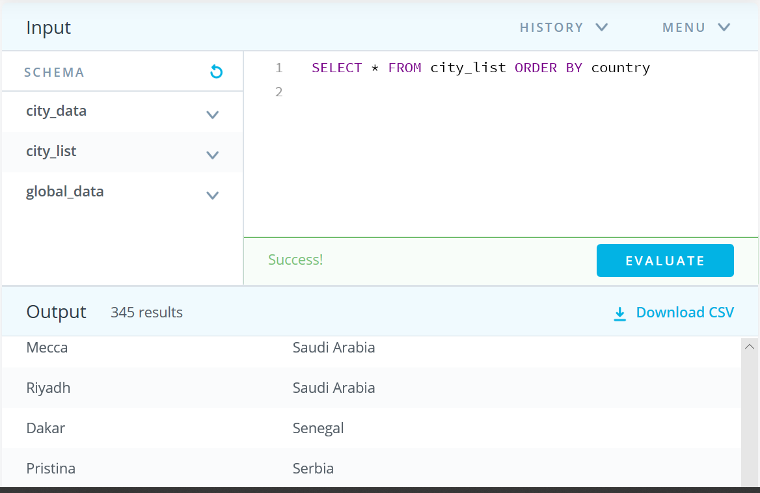

Figure 1: SQL query for extracting the cities

Figure 2 shows the SQL statement for extracting Riyadh data from city data table with a WHERE clue in order to narrow the result.

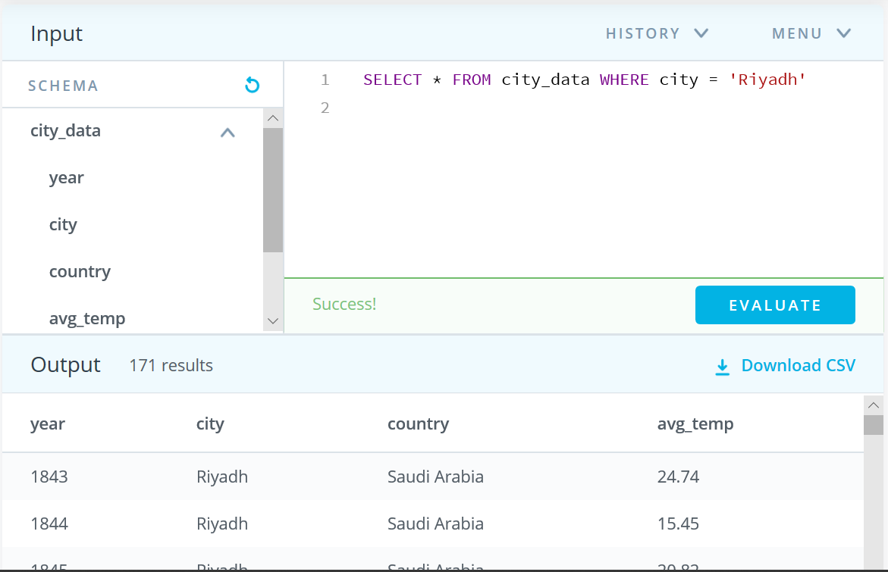

Figure 2: SQL query for extracting Riyadh temperatures

Figure 3 shows the SQL statement for extracting the global temperatures from

global data table.

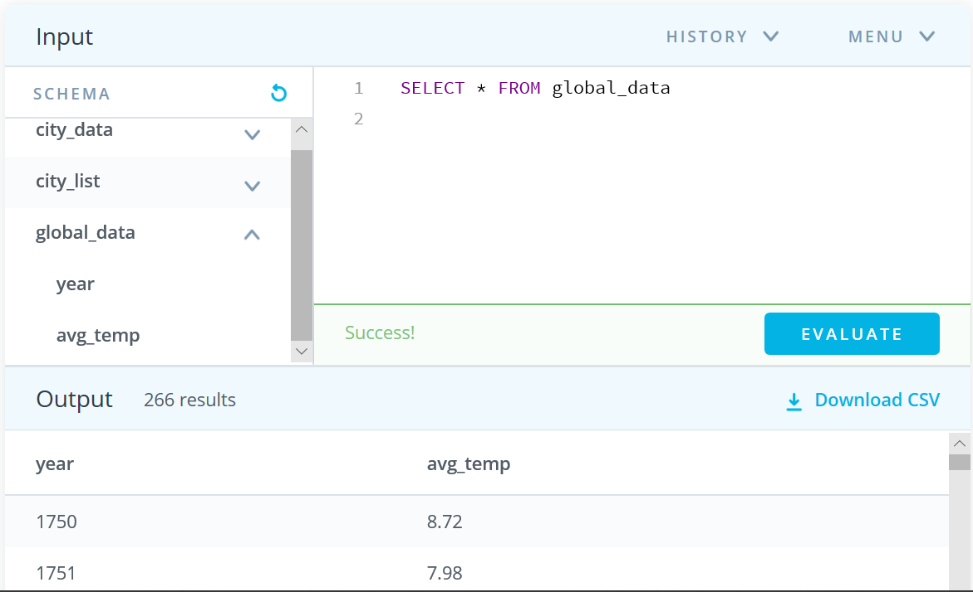

Figure 3: SQL query for extracting global temperatures

Then, I exported the results to CSV. I have used Excel to work in these results and calculate the moving average to create the line charts. Moving averages smooths the line chart and make it more understandable. Moving average can be calculated by:

First, choosing the moving average. I had set the moving average to be 10 years in order to have result that is more precise. Second, calculate the average of the first 10 data in temperature column. I used the function AVERAGE in Excel for example: AVERAGE (B2:B11). Then this step is repeated by excluding the first cell and including one cell further from the bottom (AVERAGE (B3:B12)) and so on.

**Line charts:**

Since Riyadh temperature data start from year 1843 to 2013 I used the same interval form global temperature data in order to have accurate comparison. This step can be made by the following SQL query:

SELECT * FROM global_data WHERE year Between 1843 AND 2015

Figure 4 shows the 10-Year Moving average of global temperatures and Riyadh temperatures line chart.

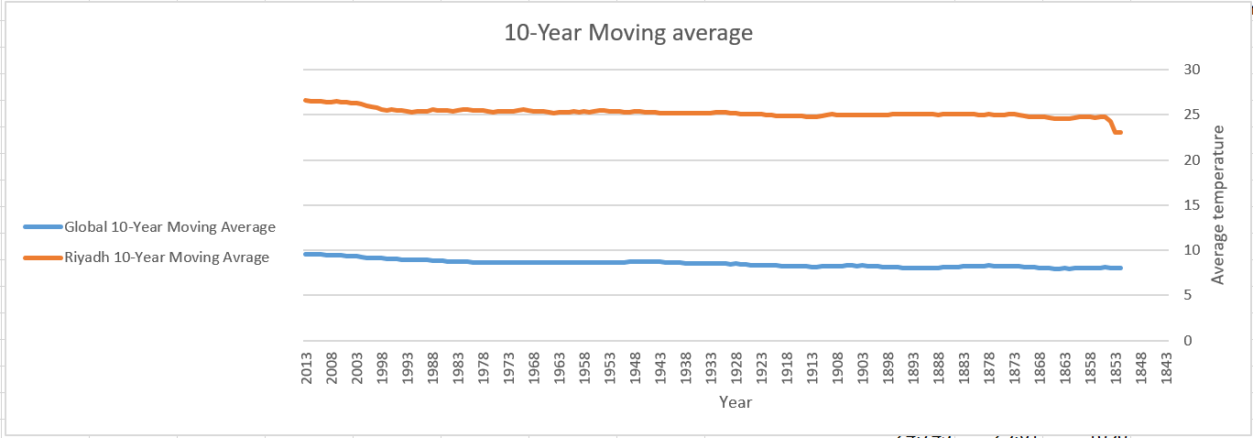

Figure 4: 10-Year Moving average of global temperatures and Riyadh temperatures

**Observations:**

**After reviewing the above charts I have come with the following observations:**

1. Changing over time matches between Riyadh and the global temperature.
2. Overall trend is increasing and the world is getting hotter.
3. Riyadh is hotter than the global average with almost a consistent difference between them.
4. The period from 1871 to 1913 can be considered consistent temperature period globally.
5. The periods from 1990 to 2013 and 1852-1856 are the fast rapid increasing periods over all the chart.

**Student name: Makarem Al-Salman**

**Connect - Data Analyst**